H.U. MECHANICAL ENGINEERING

GENERAL CHEMISTRY LAB REPORT

PH

GÖKAY KART

KIM-121-6

CANAN ARMUTÇU

Aim

The purpose of this experiment is to find the experimental Ph values of Boric acid and Ammonia. While finding these values, we used two substances of which Ph values are known by using solution dilution method.

Arrhenius Theory

Arrhenius proposed that in aqueous solutions, strong electrolytes exist only in the form of ions, whereas weak electrolytes exist partly as ions and partly as molecules. Arrhenius's theory can adequately explain the behavior of acids and bases.

To explain with an example, (in aqueous solution of NH3)



Nh3 is the base as it supplies the hydroxide ion (OH¯) to the solution.

Also, the substances that give the hydrogen ion (H +) to the solution are acids.

Lewis Theory

According to the Lewis theory, acids are electron acceptors and bases are electron donors.

To explain with an example,

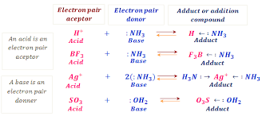

Brønsted-Lowry theory

The basic concept of the theory is that acids are substances that donate protons (H + ions) and bases are substances that receive protons.

* Acids are proton donors.
* Bases are proton acceptors.

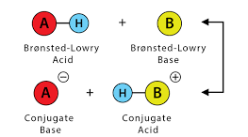

To explain with an example, (HCI-NH3)

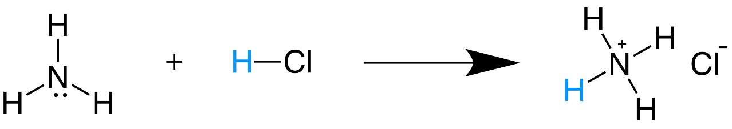

Conjugate Acids & Bases

* Conjugate acid is the type formed by the proton uptake (H +) of a base.
* Conjugate base is the type that is formed after the acid donates protons.

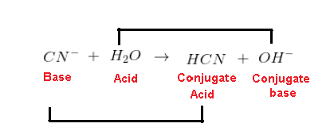

Strong and Weak Acids

* Strong acids ionize completely in aqueous solution.
* Weak acids ionize only partially in aqueous solution.
* A stronger acid will produce a weaker conjugate.
* A weaker acid will produce a stronger conjugate.

To explain with an example,

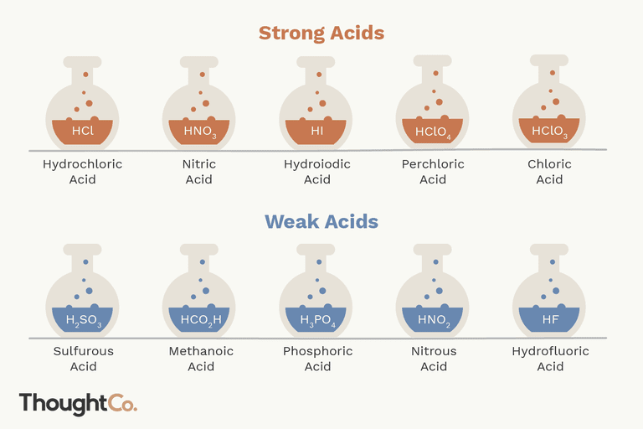

If we show it graphically,

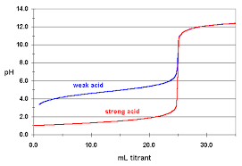

Most important difference between strong and weak acids: once the reaction reaches equilibrium, strong acids will be dominantly in the conjugate base form. Weak acids will exist as a mixture of the original acid and the conjugate base form.

Strong and Weak Bases

* Strong bases ionize completely in aqueous solution.
* Weak bases ionize only partially in aqueous solution.
* A stronger base will produce a weaker conjugate.
* A weaker base will produce a stronger conjugate.

To explain with an example,

* LiOH - lithium hydroxide
* NaOH - sodium hydroxide
* KOH - potassium hydroxide
* RbOH - rubidium hydroxide
* CsOH - cesium hydroxide

If we show it in Ph meter,

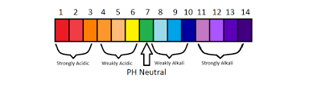

Ka, Kb, Kw, pKa, pKb, pKw

We use a specific type of equilibrium constant when describing the dissociation reactions of acids and bases.

* Ka is the acidity equilibrium constant.
* Kb is the basic equilibrium constant.
* Kw is the water ionization constant.
* Pure water at 25 C: [H3O+] = [OH-] = 1.0 x 10-7 M
* The unit of equilibrium constants is Molarity. (mol / liter)

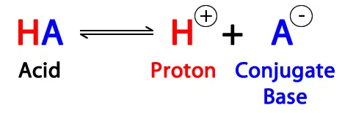

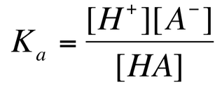

Likewise, the equilibrium constant for a base dissociation is given by Kb, its Base Dissociation Constant.

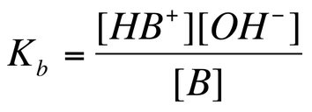

* The product of K of conjugated acid base pairs gives Kw.

metin içeren bir resim

Açıklama otomatik olarak oluşturuldu

* This simple equation converts between Ka, Kb, Kw and pKa, pKb, pKw.

metin içeren bir resim

Açıklama otomatik olarak oluşturuldu

Neutralization

Acid + Base 🡪 Salt + Water

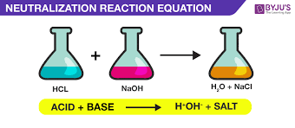

What is the pH scale?

pH is a measure of how acidic/basic water is. The range goes from 0 - 14, with 7 being neutral. pH of less than 7 indicate acidity, whereas a pH of greater than 7 indicates a base.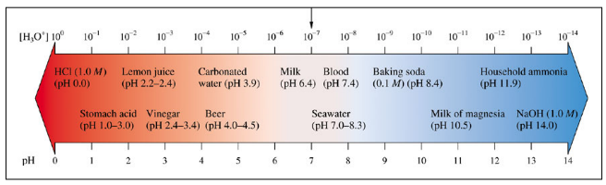

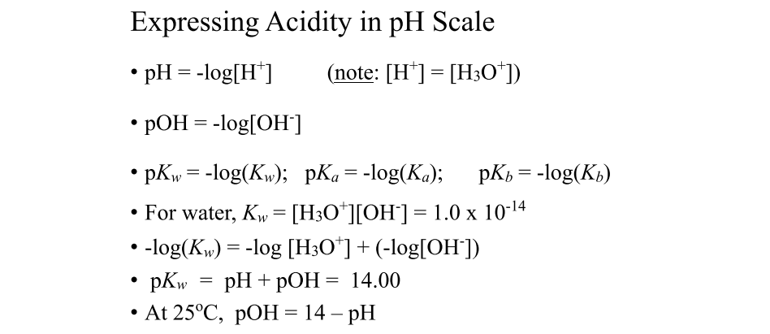

* Ph values are measured with a Ph meter.
* It is measured with various indicators.

To explain with an example,

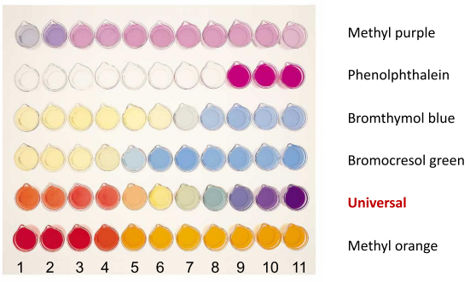

Data of the experiment;

Experiment-1

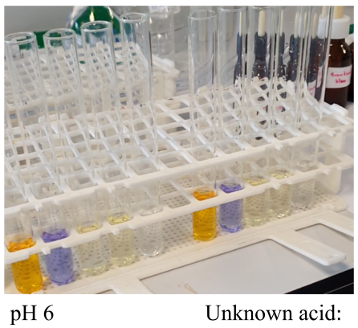

Experimen-2

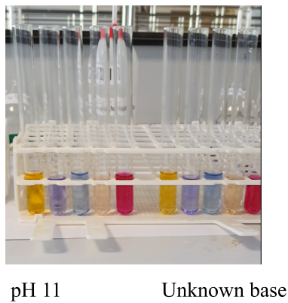

Calculations of the experiment;

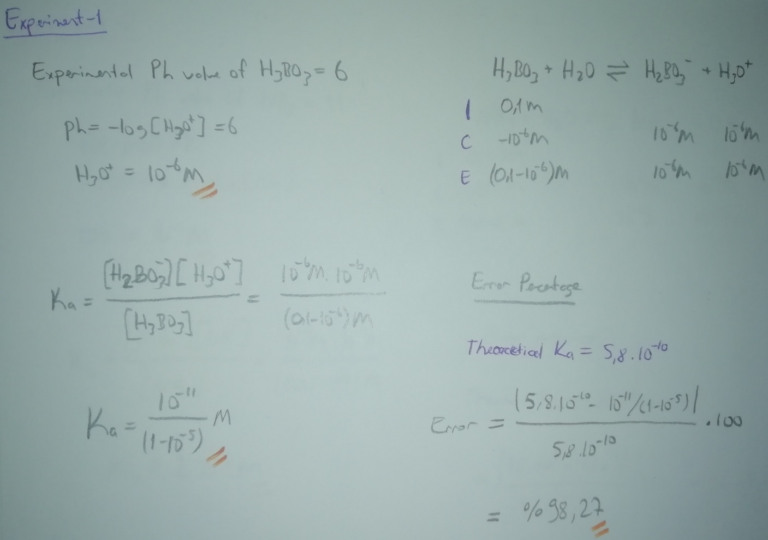

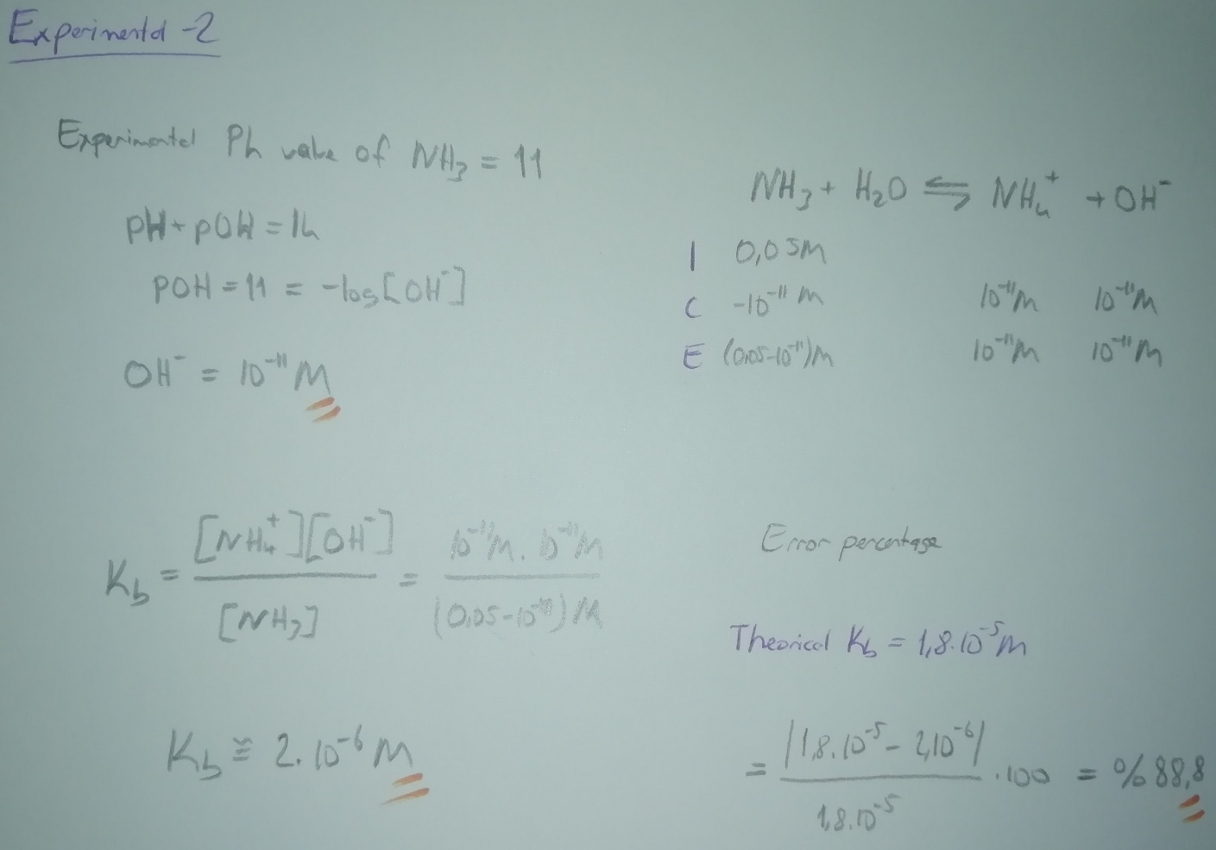

Results of the experiment;

Experiment-1(H3BO3)

pH= 6

[H3O+] = 1x10-6 M

Ka=1x10-11/(0,1-1x10-5)

Percent dissociation = %1x10-3

%Error=98,27

Experiment-2(NH3)

pOH= 3

[OH-] = 1x10-3 M

Kb=1x10-3/(0,05-1x10-3)

Percent dissociation = %2

%Error=88,88

Discussion part of the experiment;

The purpose of this experiment is to find the Ph values of the two substances. While finding these values, we used two substances with known pH values.

Experiment making process

Experiment 1

We added 25 ml of HCl to 5 test tubes. (Value 10-3 M) Then we added 45 ml pure water to a separate 5 ml HCl with the help of the formula M1xV1 = M2xV2. We made the new molarity 10-4M. We added the solution in 5 ml form to 5 new tubes. We separated 5 ml of solution and put the excess substance in the waste container. Then we did the same 3 more times. The change in molarity was 10-3> 10-4M> 10-5M> 10-6M> 10-7M. Finally, we took 25 ml of 0.1 M boric acid and added 5 ml to 5 tubes each.

* For testing, we have 6 rows of 5 test tubes.
* In the first place, there is pure HCI whose ph value we know.
* There are solutions prepared by solution dilution method in the 2nd, 3rd, 4th and 5th rows.
* In the 6th row, there is pure boric acid (H3BO3) for which we do not know the ph value.
* 5 different indicators are added to the test tubes.
* Methyl orange indicator was added to the 1st test tube of each row.
* Bromine phenol blue indicator was added to the 2nd test tube of each row.
* Bromthymol indicator blue was added to the 3rd test tube of each row.
* Alizarin yellow indicator was added to the 4th test tube of each row.
* Phenolphthalein indicator was added to the 5th test tube of each row.
* At the end of the addition we shake out all the solutions.

Experiment 2

In the second experiment, we prepared the tubes with NaOH instead of HCl. In the 6th row, we added ammonia for which we do not know the ph value and we added the indicator in the same order.

Observation process

Experiment 1

* Finally, we take 5 boric acid tubes to observe and compare the colors of the 1st, 2nd, 3rd, 4th and 5th solutions in turn.
* According to the observation result, we found the ph value of 6.
* The theoretical boric acid ph value is 5.1.
* The error rate from the Ka value is 98.27%.

Experiment 2

* Finally, we get 5 ammonia tubes to observe and compare the colors of the 1st, 2nd, 3rd, 4th and 5th solutions, respectively.
* According to the observation result, we found the ph value of 11.
* The theoretical ph value of ammonia is 11.5.
* Error rate from Kb value is 88.88%.

Color ranges of used indicators

Methyl orange, purple> red> pink> orange> yellow makes the color transformation in acids and contains 7-14 yellow tones in bases. The pH range is 3.1-4.5. Methyl orange is a useful indicator as a color scale and should be used in acids.

Bromine phenol blue acid color is yellow, base color is blue. The ph range is 3.0 - 4.6. Bromine phenol blue can be used in medium-weak class acids. Its usage area is limited.

Bromthymol indicator transforms acids from yellow to green, bases blue tones. The pH range is 6.0 - 7.6. Bromthymol indicator is generally average in ph color scale since its values ​​close to neutral are greenish. Used on weak bases.

Alizarin is yellow in yellow acids and red in bases. The ph range is 10.0-12.1. Used in middle-high grade bases.

Phenolphthalein is colorless in acids, while bases have a light pink to dark pink tint. The ph range is 8.3-10.0. It is used to give a clear answer to the acid base problem. It is used in medium-weak bases.

To get better results in the experiment;

* The purity of the products used in the experiment is very important.
* While the solutions are being prepared in the experiment, the solution is transferred to a separate container to prepare a new solution. In this process, the container should be cleaned after the solution is used, that is, the resulting molarity changes should be complete.
* Indicator selections should be made by paying attention to the pH ranges in order to obtain a healthier and safer result.
* Indicators with a wide color scale and classified according to the acidity or base of the selected substances should be preferred.
* Indicators should be added to the solutions in golden ratio to get a healthy image.
* After adding the indicators, they should be mixed sufficiently.
* For a more accurate observation, the number of indicators should be increased.
* The light factor of the environment should be improved for observation.

As a result, error rates will be minimized when these factors are taken into consideration.

Questions & Answers:

1)Why is the pH of distilled water contains dissolved CO2 less than 7? Explain with related equations.

The pH of distilled water immediately after distillation is 7, but within hours after distillation, it has absorbed carbon dioxide from the atmosphere and become acidic with a pH of 5.8.

**2H20 + CO2 --> H2O + H2CO3 (carbonic acid) --> H3O+ (hydronium) + HCO3- (bicarbonate ions)**

2) Calculate the percent dissociation of week acid or weak base which used.

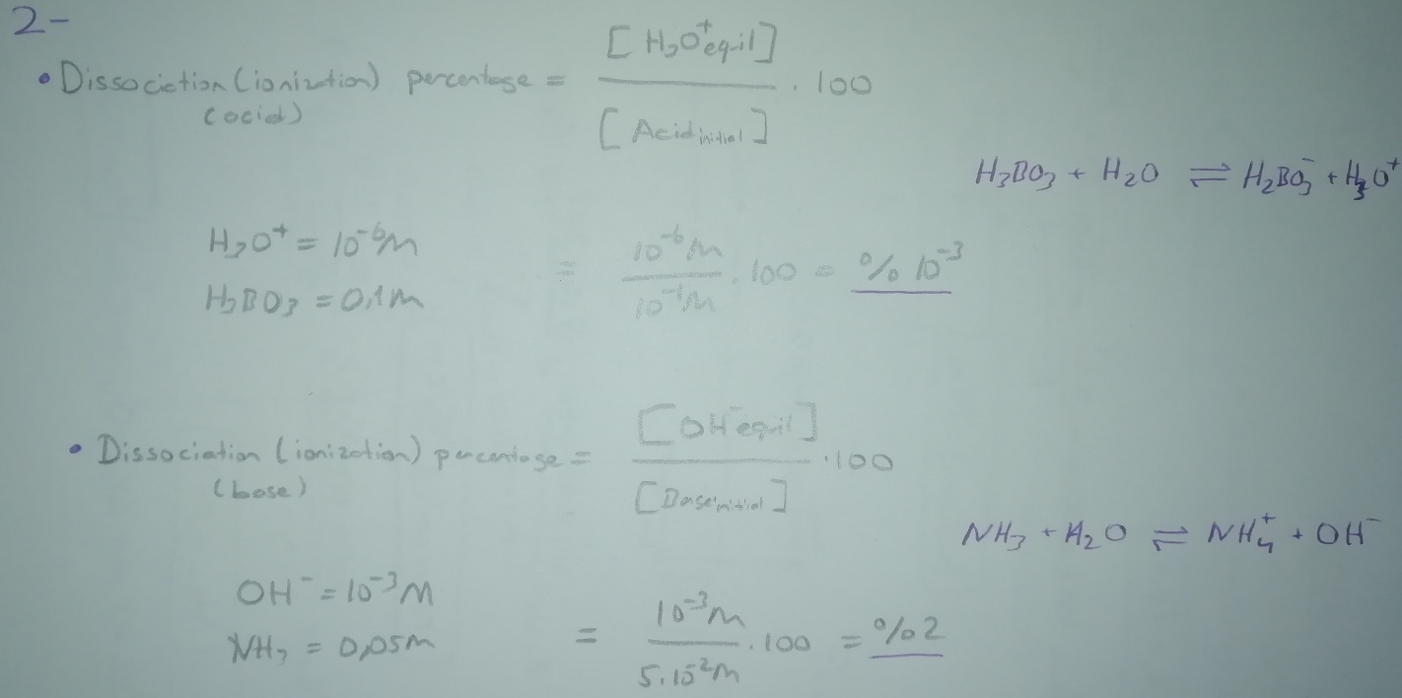

Referenced sources:

Websites:

<https://tr.wikipedia.org/>

<http://www.kimyaevi.org/>

<https://www.thoughtco.com/>

<https://www.greelane.com/>

Books:

General Chemistry Principles and Modern Applications (10th Edition, Chapter 16 and Chapter 17).